Assignment 2

Step 1: Created Jira Scrum Project:

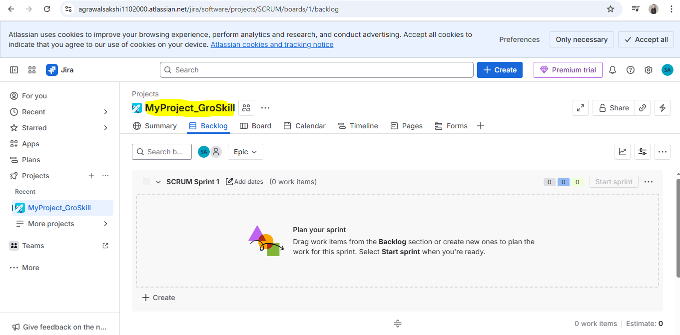

Step 2: Created Epic for “Guru 99 demo application”:

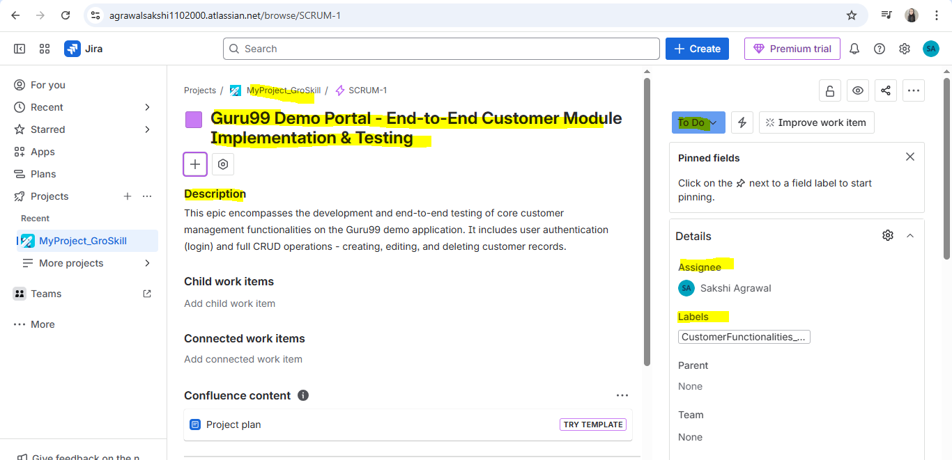

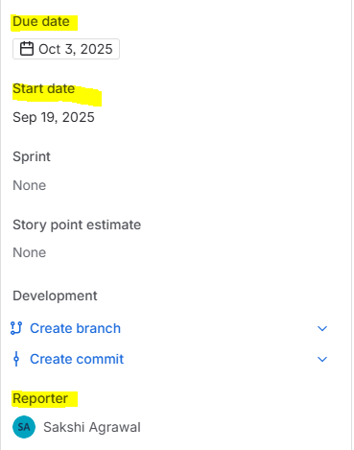

Now, create 4 User stories regarding(Login, Create Customer, Edit Customer and Delete Customer functionalities) inside this epic

Step 3: Drafted a user story for Login functionality:

Link to the user story: <https://agrawalsakshi1102000.atlassian.net/browse/SCRUM-2>

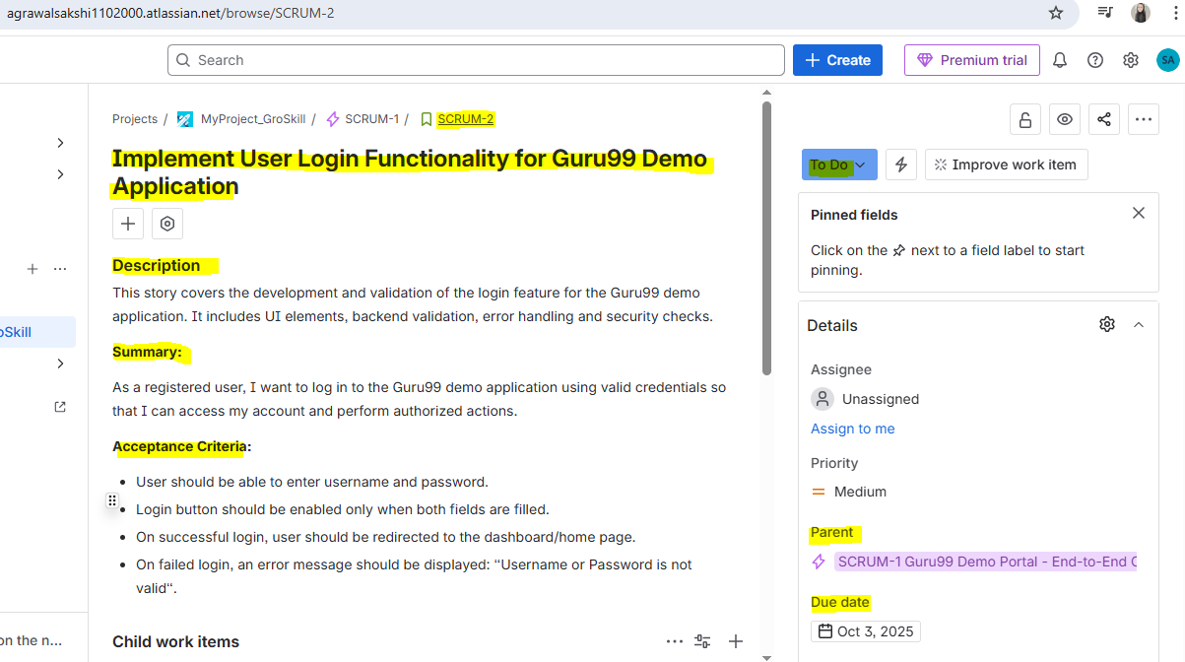

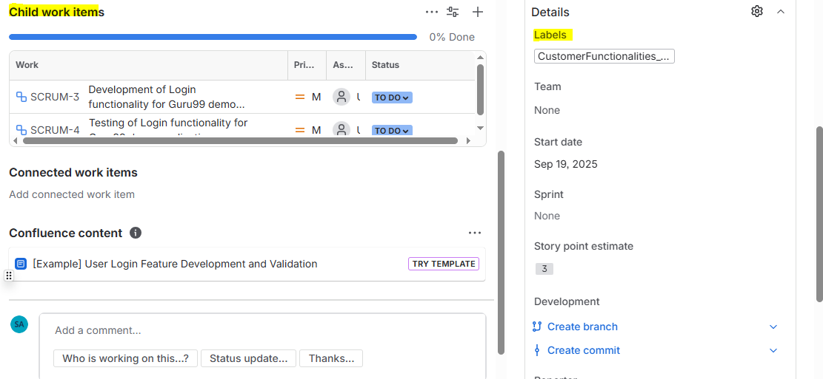

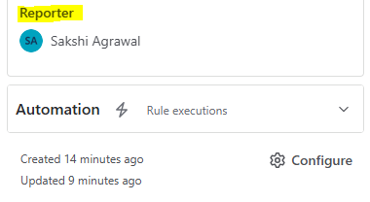

Created a Subtask in the above user story for the development of Login functionality:

Link to the subtask: <https://agrawalsakshi1102000.atlassian.net/browse/SCRUM-3>

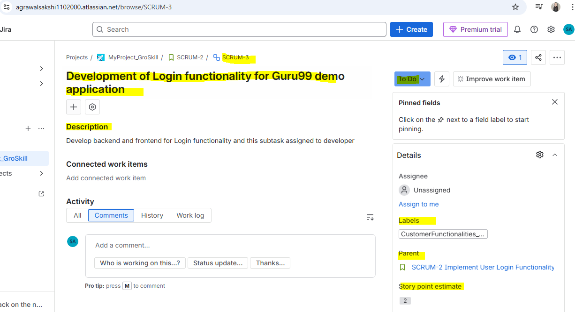

Created a Subtask in the above user story for the Testing of Login functionality:

Link to the subtask: <https://agrawalsakshi1102000.atlassian.net/browse/SCRUM-4>

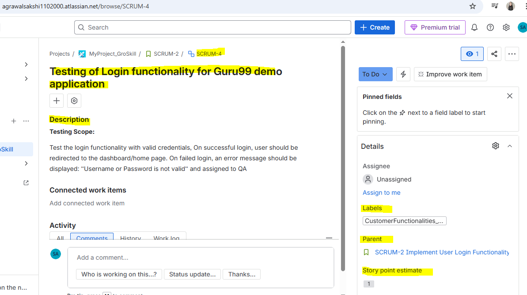

Step 4: Drafted a user story for “Create Customer” functionality:

Link to the user story: <https://agrawalsakshi1102000.atlassian.net/browse/SCRUM-5>

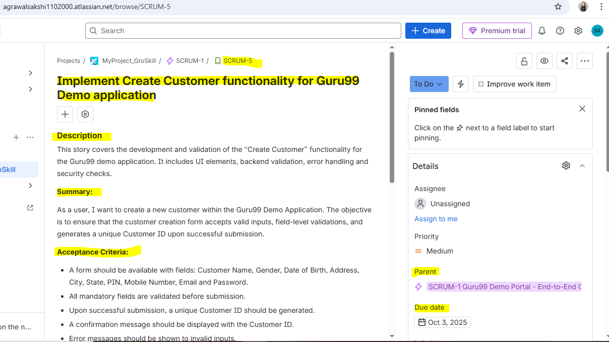

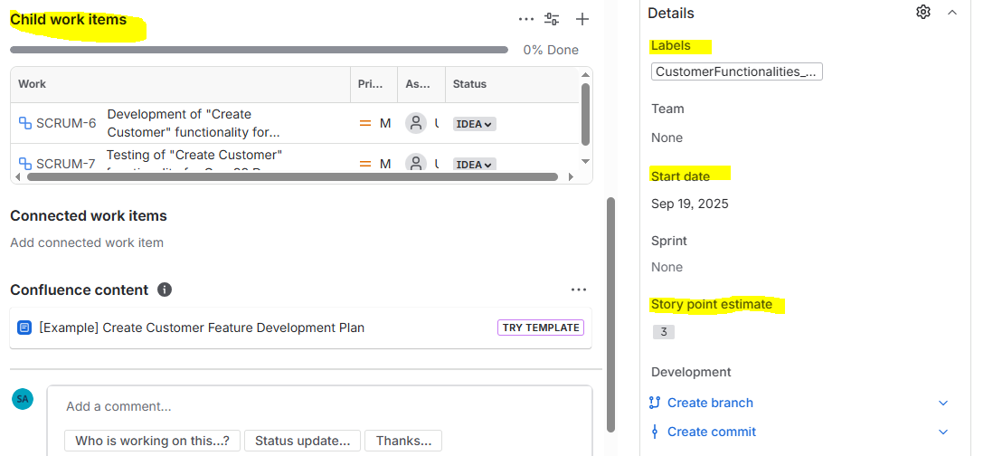



Created a Subtask in the above user story for the development of “Create Customer” functionality:

Link to the subtask: <https://agrawalsakshi1102000.atlassian.net/browse/SCRUM-6>

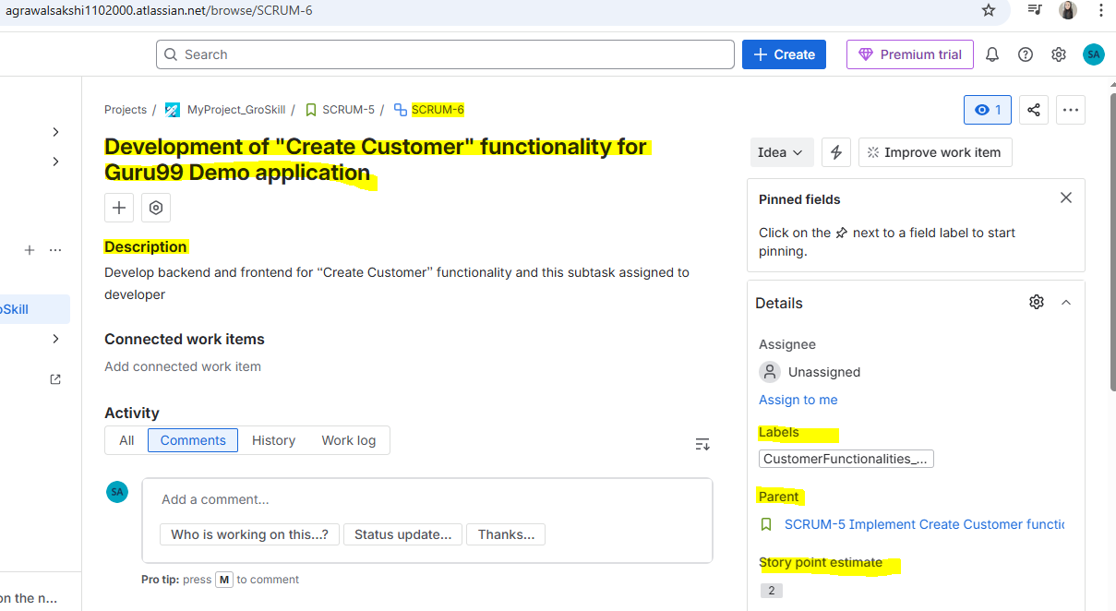

Created a Subtask in the above user story for the testing of “Create Customer” functionality:

Link to the subtask: <https://agrawalsakshi1102000.atlassian.net/browse/SCRUM-7>

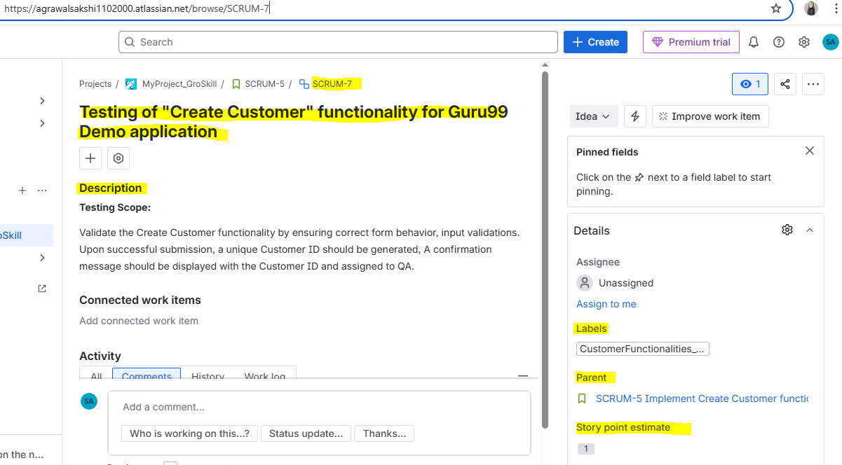

Step 5: Drafted a user story for “Edit Customer” functionality:

Link to the user story: <https://agrawalsakshi1102000.atlassian.net/browse/SCRUM-8>

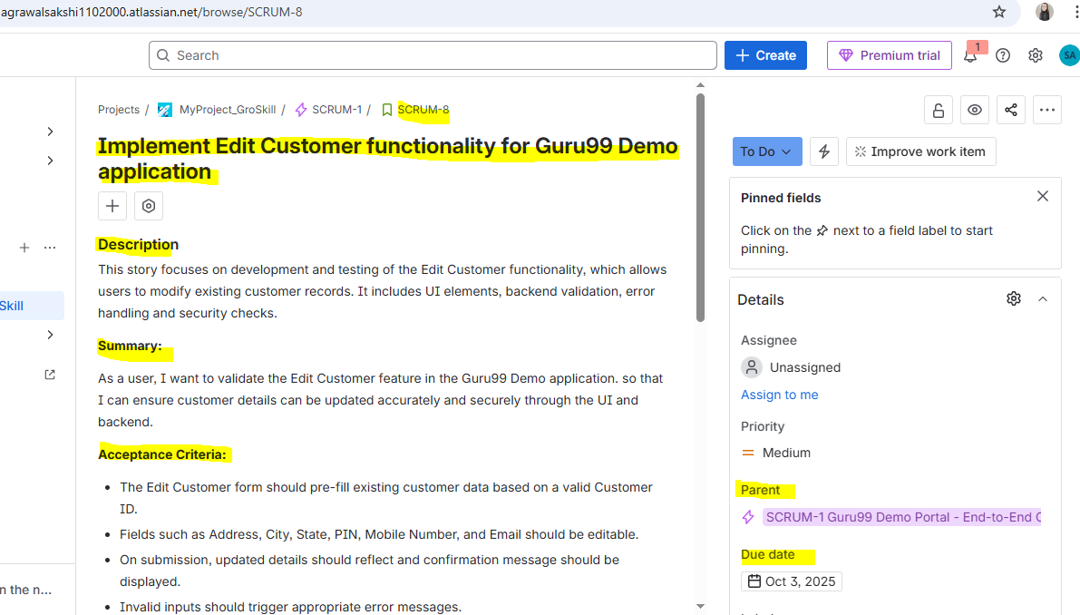

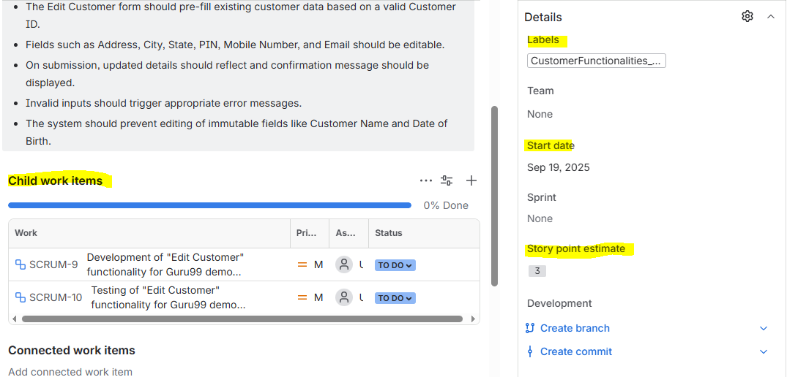

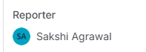

Created a Subtask in the above user story for the development of “Edit Customer” functionality:

Link to the subtask: <https://agrawalsakshi1102000.atlassian.net/browse/SCRUM-9>

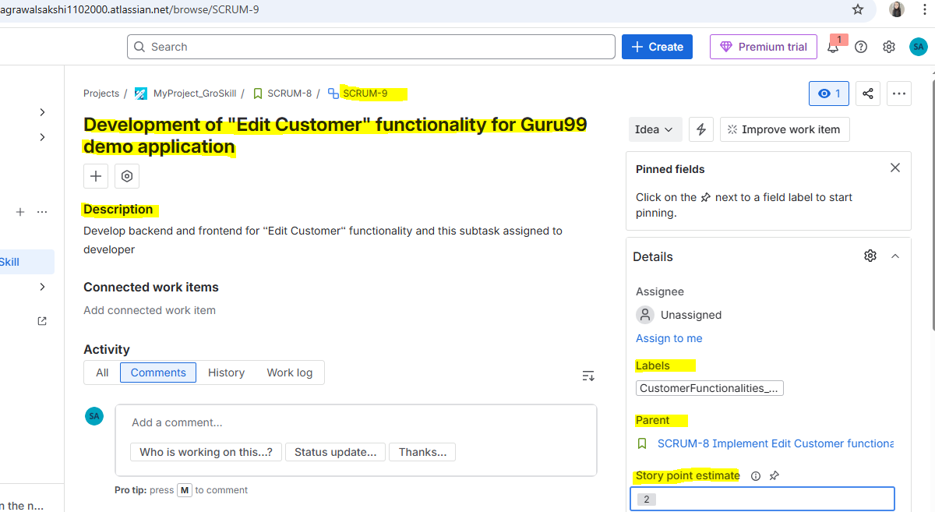

Created a Subtask in the above user story for the testing of “Edit Customer” functionality:

Link to the subtask: <https://agrawalsakshi1102000.atlassian.net/browse/SCRUM-10>

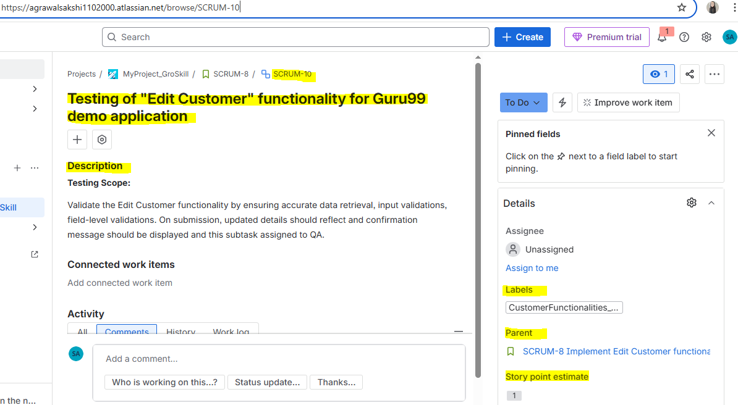

Step 5: Drafted a user story for “Delete Customer” functionality:

Link to the user story: <https://agrawalsakshi1102000.atlassian.net/browse/SCRUM-11>

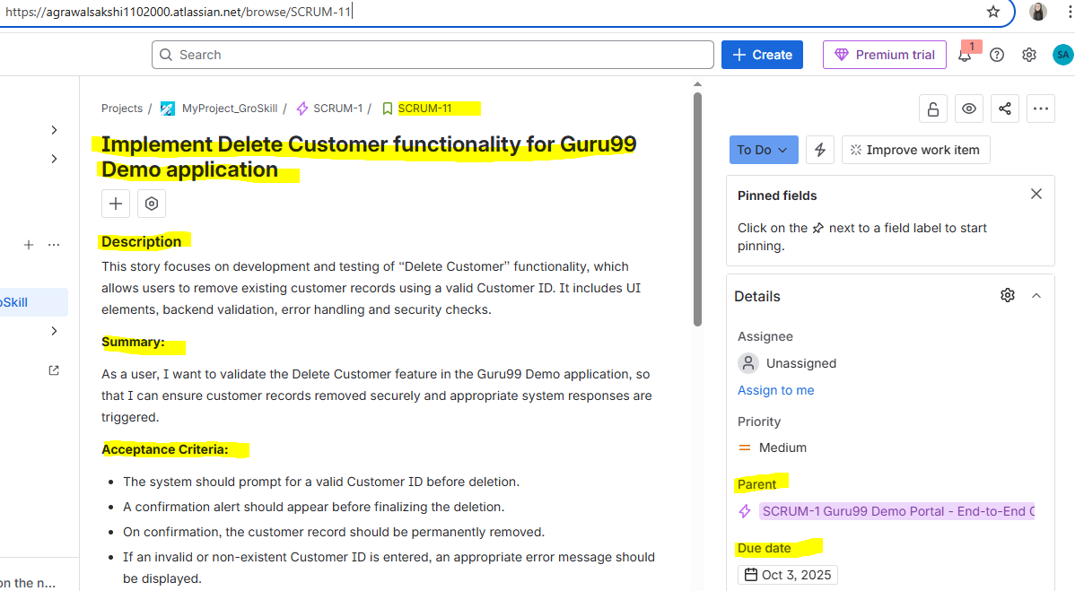

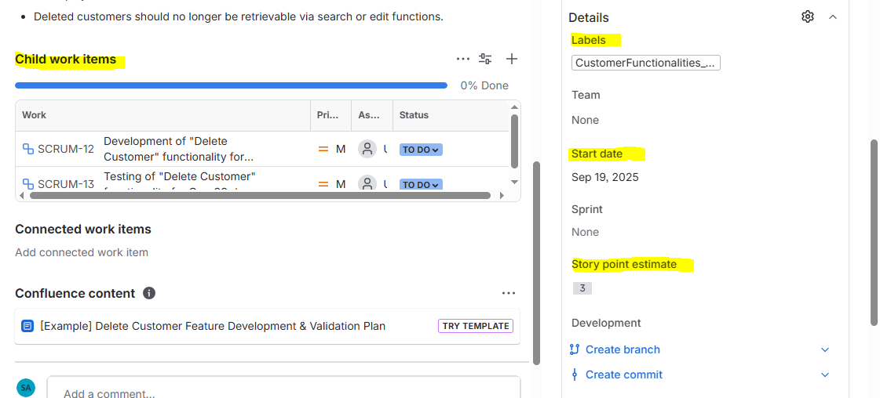

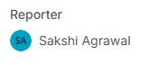

Created a Subtask in the above user story for the development of “Delete Customer” functionality:

Link to the subtask: <https://agrawalsakshi1102000.atlassian.net/browse/SCRUM-12>

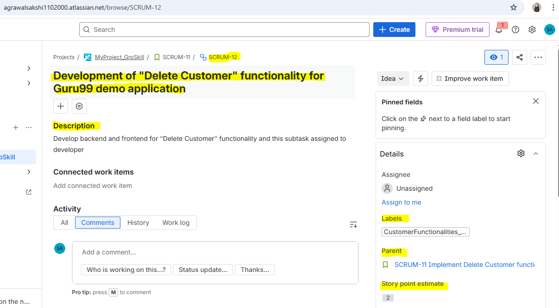

Created a Subtask in the above user story for the testing of “Delete Customer” functionality:

Link to the subtask: <https://agrawalsakshi1102000.atlassian.net/browse/SCRUM-13>

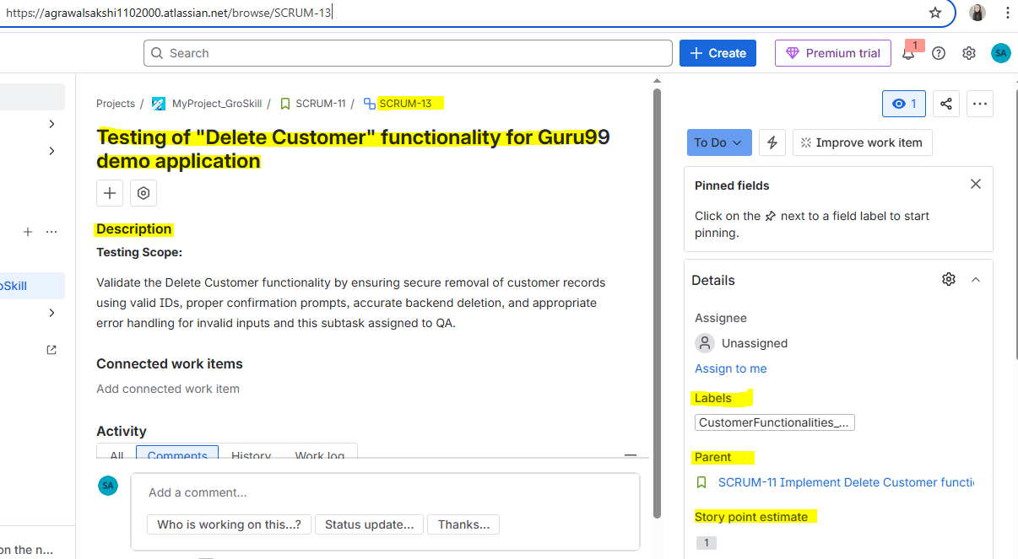

Step 6: Link Test Case to respective user story:

For User Story SCRUM-2 (<https://agrawalsakshi1102000.atlassian.net/browse/SCRUM-2>), test case is linked:

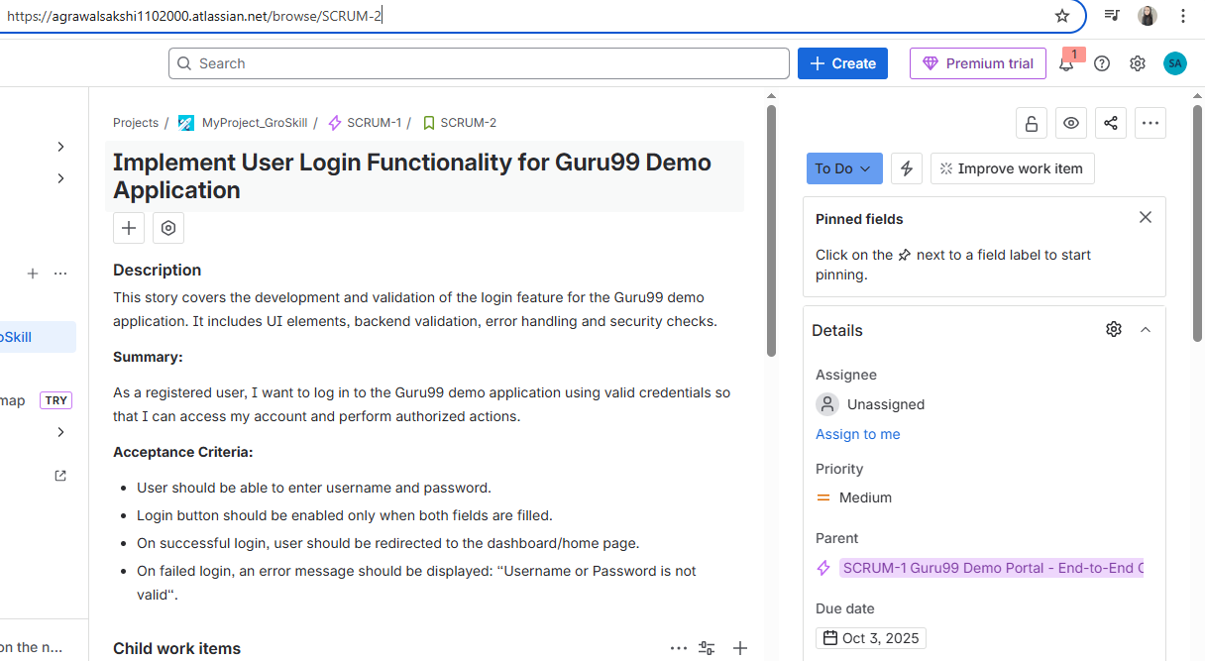

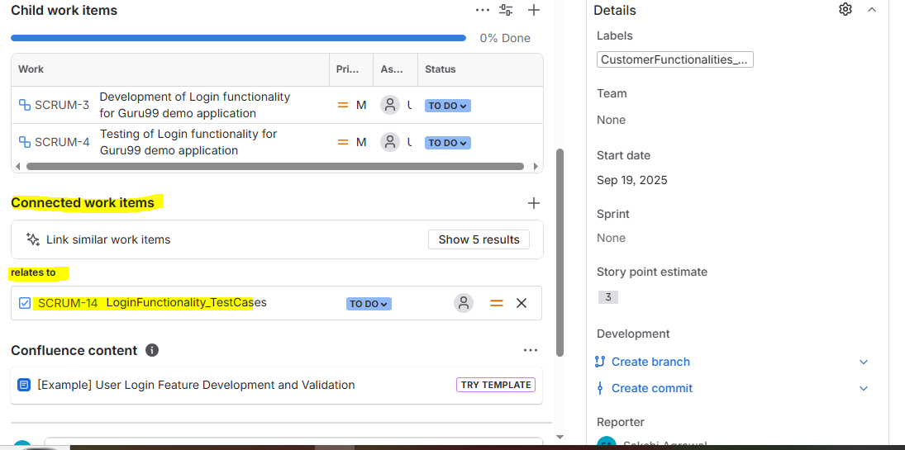

Test Case (SCRUM-14):

Test cases are attached

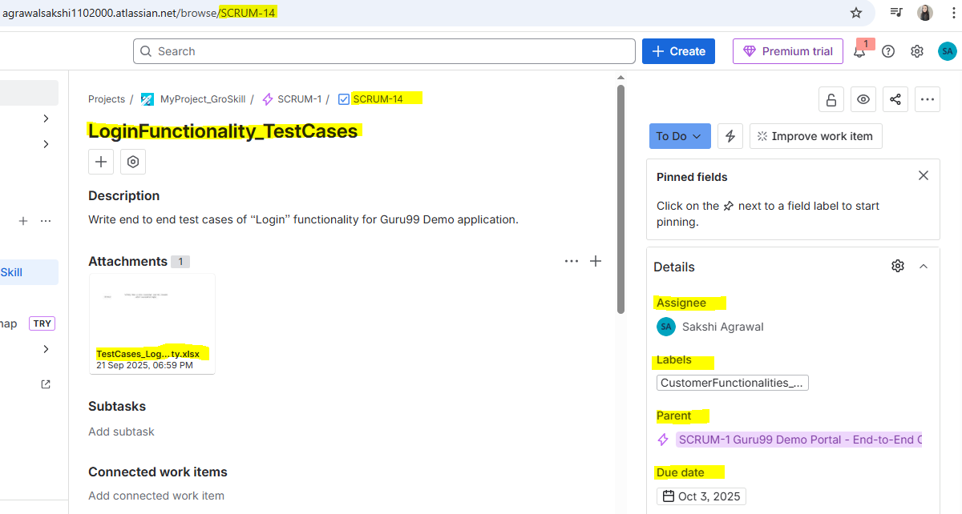

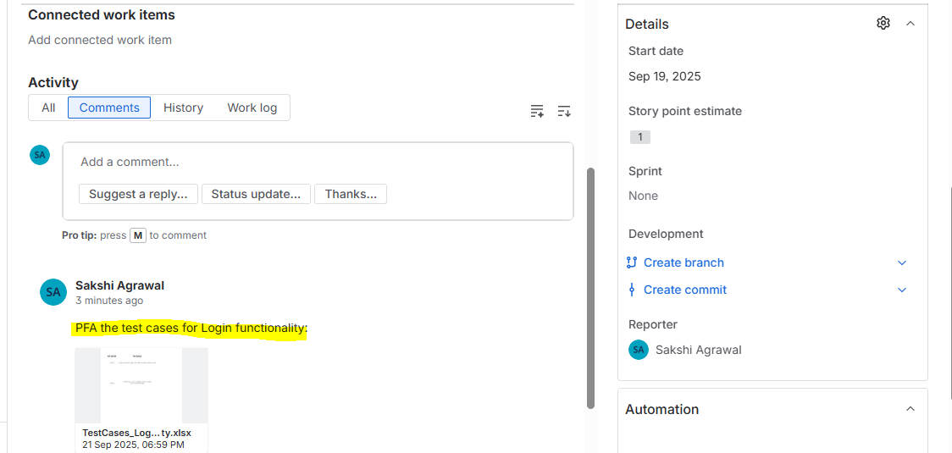

For User Story SCRUM-5 (<https://agrawalsakshi1102000.atlassian.net/browse/SCRUM-5>), test case is linked:

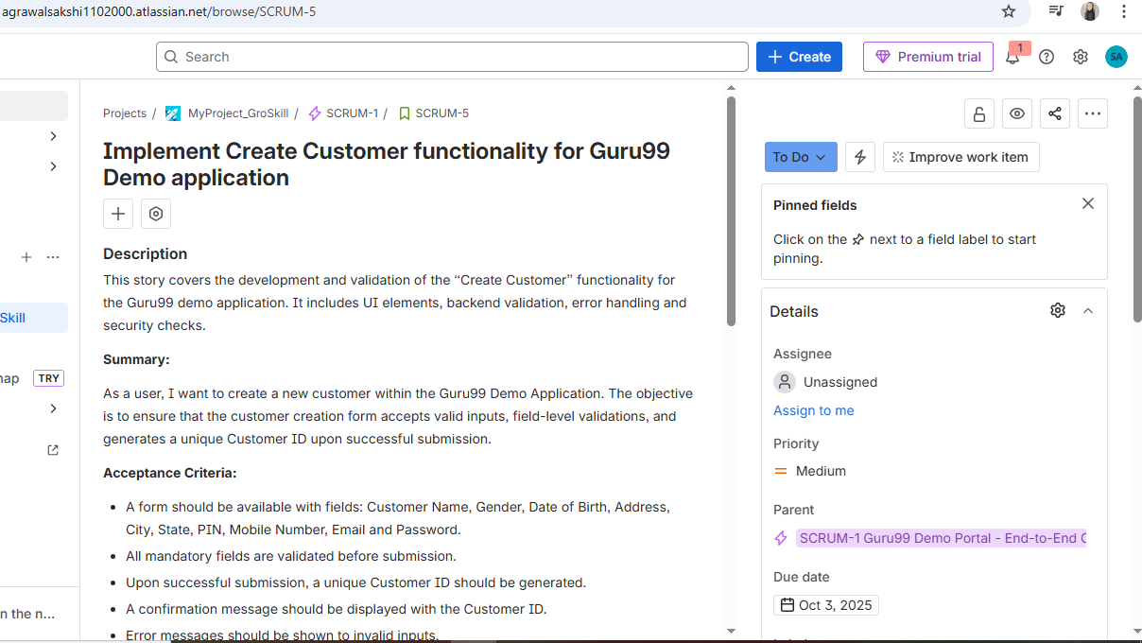

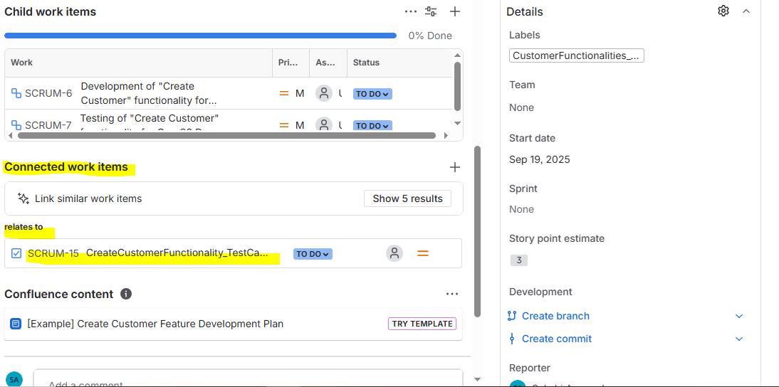

Test Case (SCRUM-15):

Test cases are attached

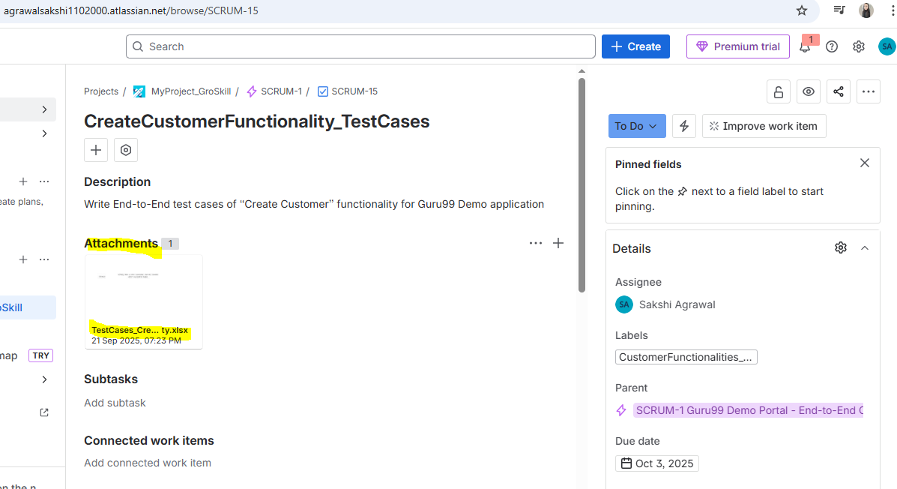

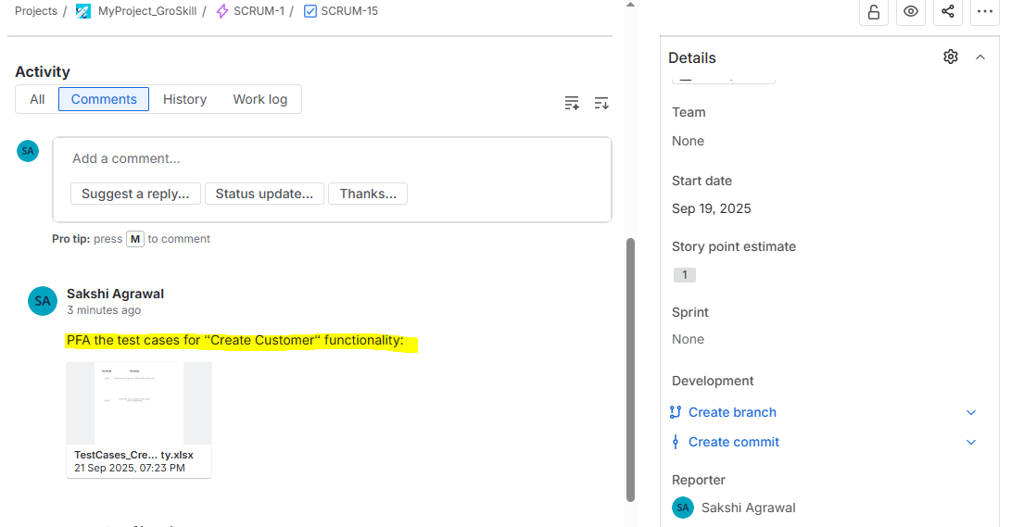

For User Story SCRUM-8 (<https://agrawalsakshi1102000.atlassian.net/browse/SCRUM-8>), test case is attached:

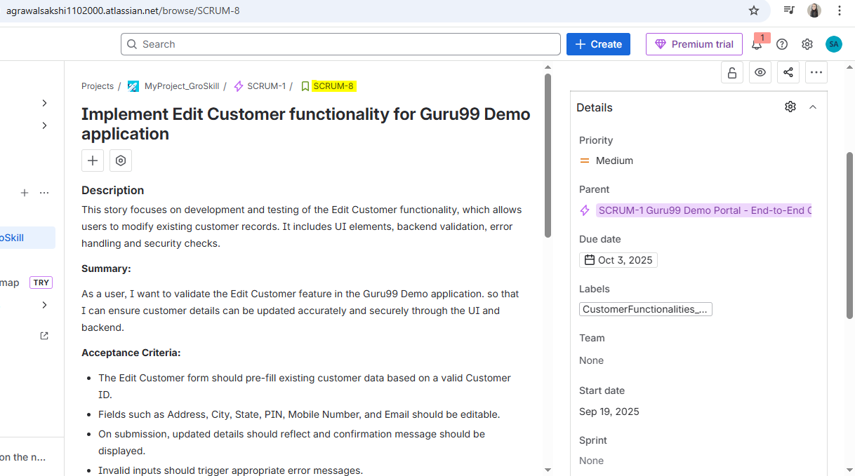

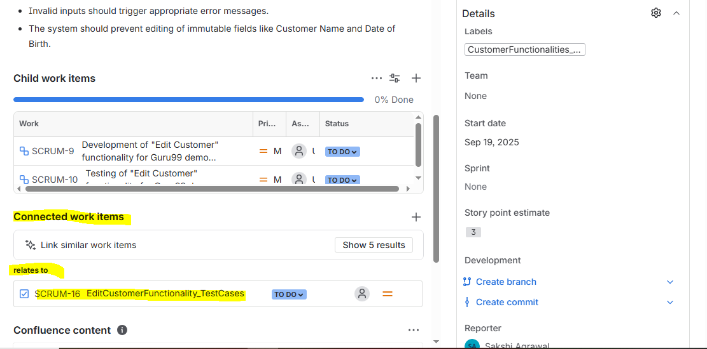

Test Case (SCRUM-16):

Test cases are attached

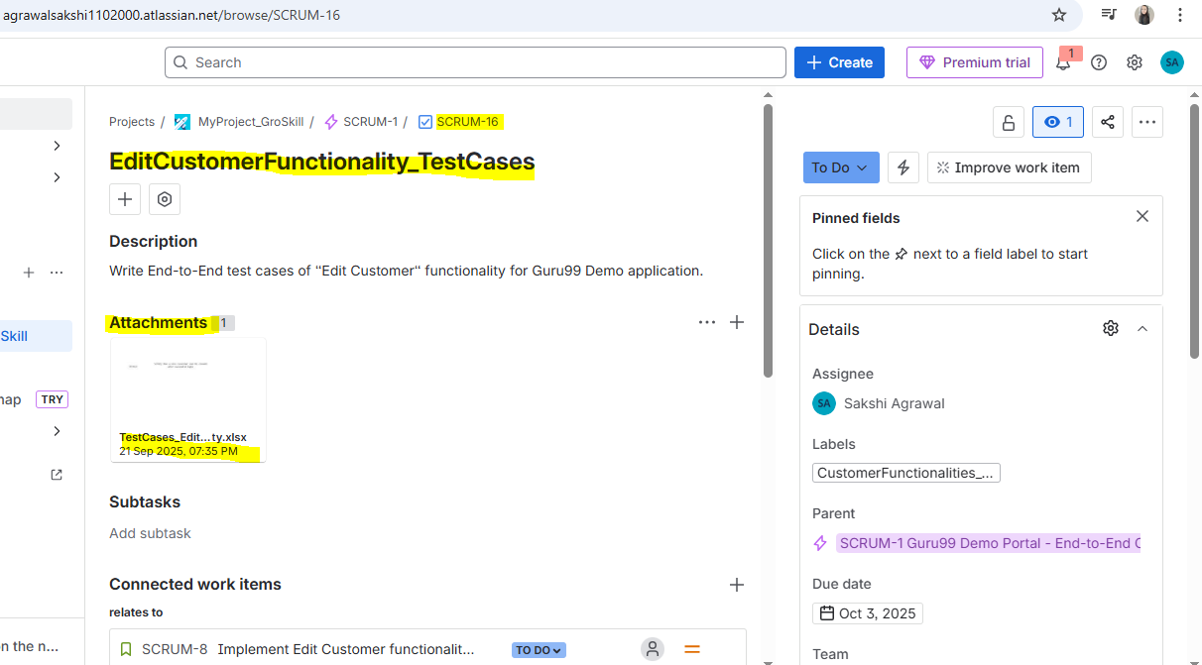

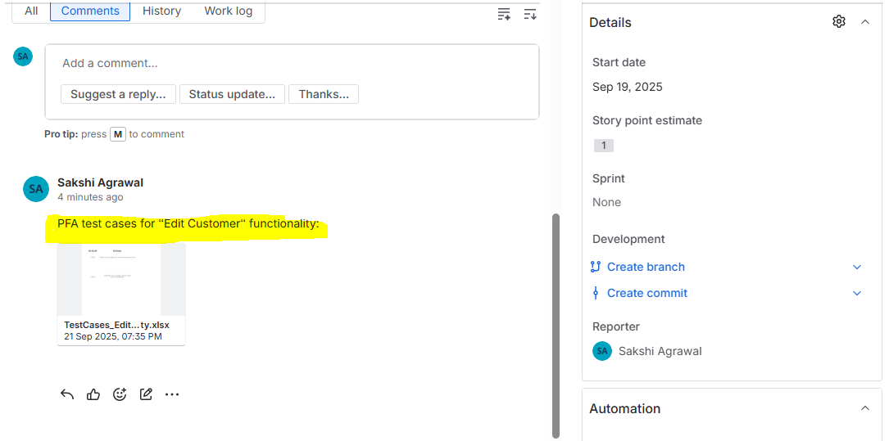

For User Story SCRUM-11 (<https://agrawalsakshi1102000.atlassian.net/browse/SCRUM-11>), test case is attached:

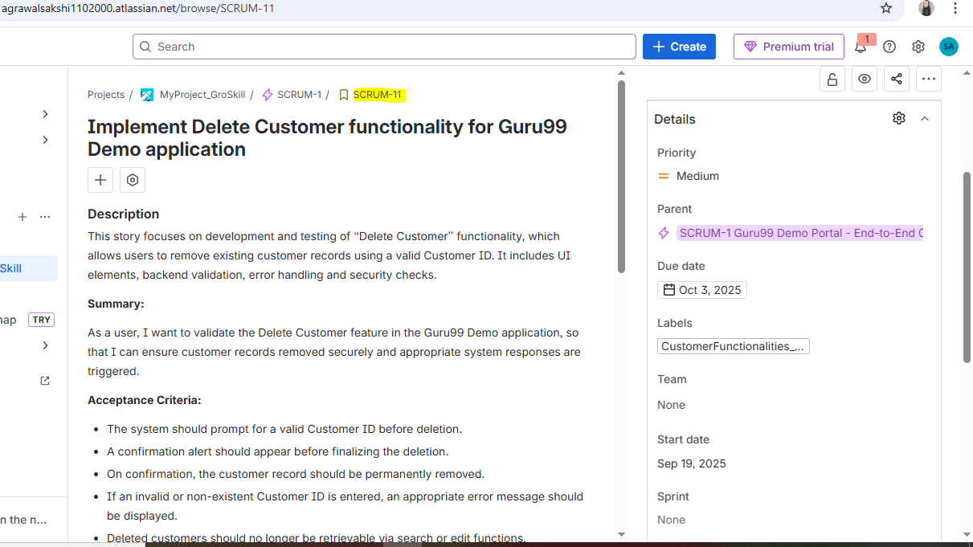

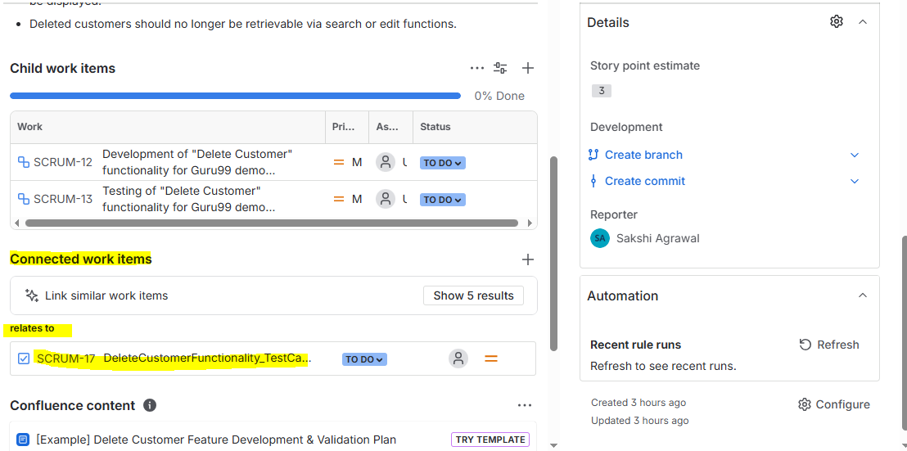

Test Case (SCRUM-17):

Test cases are attached

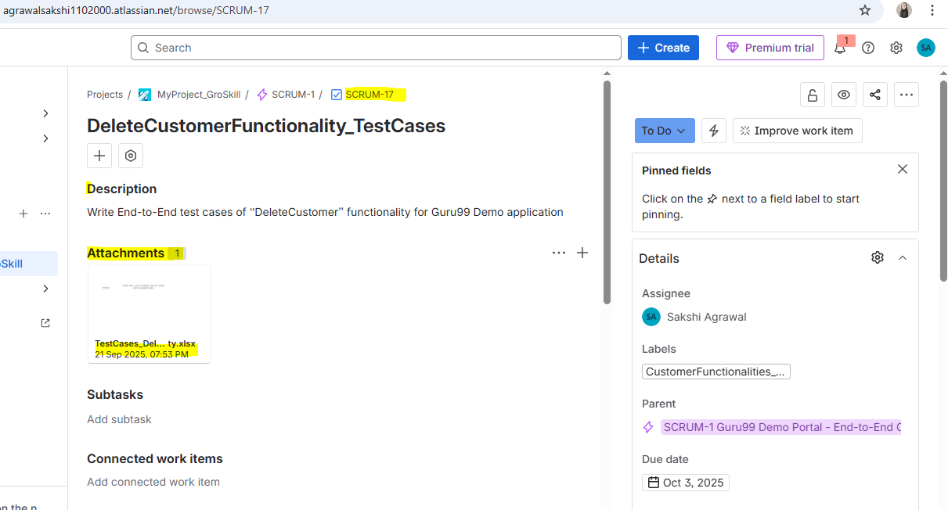

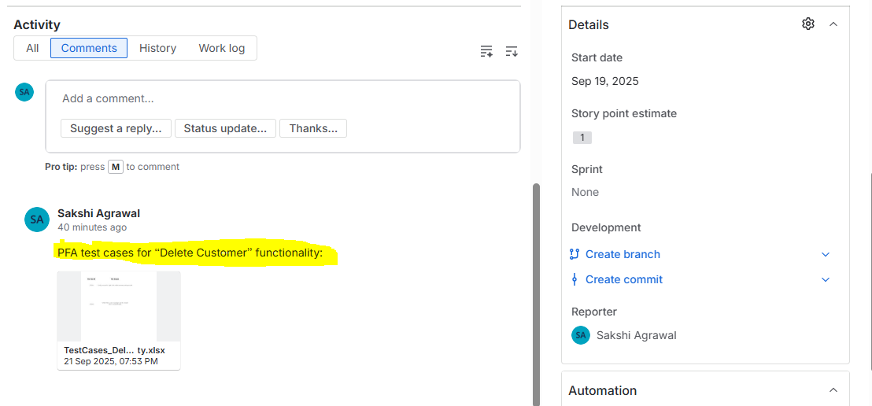

All user stories and test cases are in Backlog:

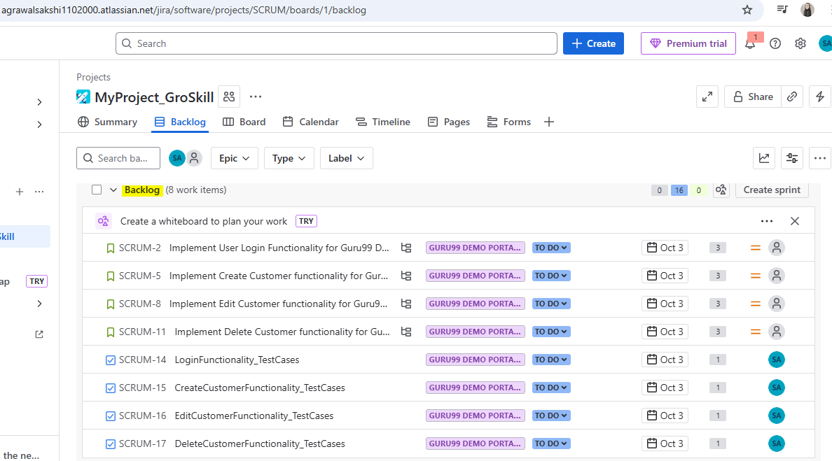

Move user stories and test cases to Current Sprint

Now, all the Stories and Test Cases are in Current Sprint:

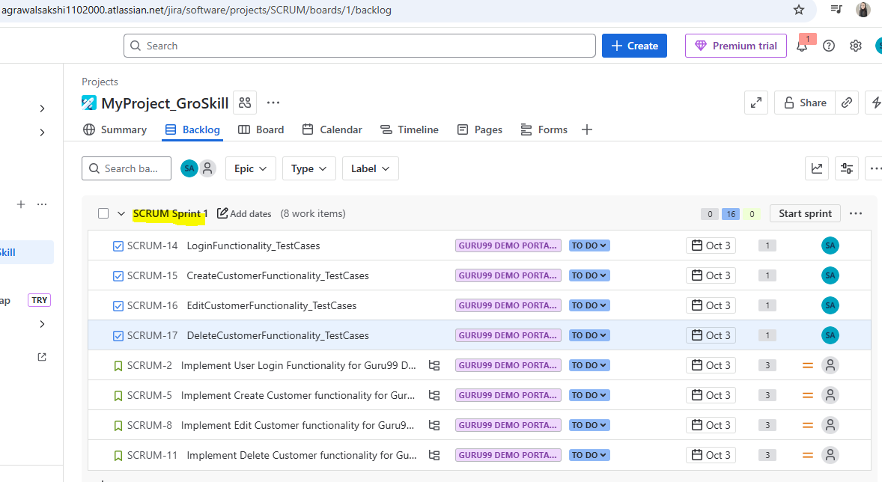

Now, Start the Sprint:

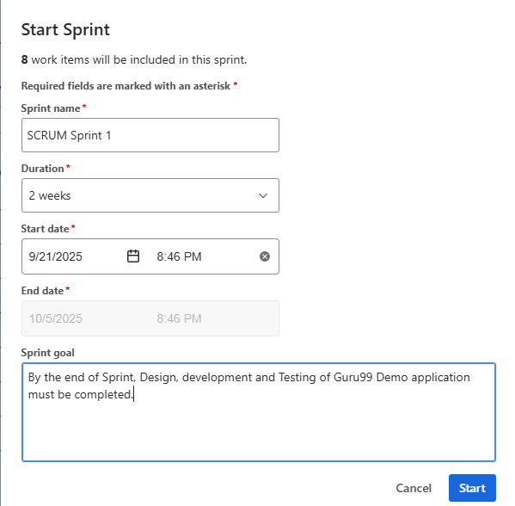

Sprint Started:

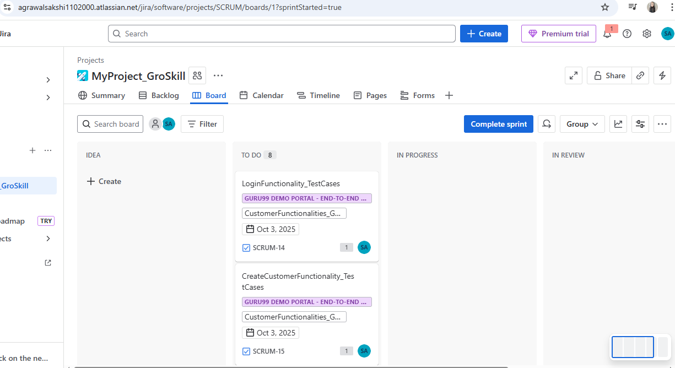

Move the Story to “In Progress” status:

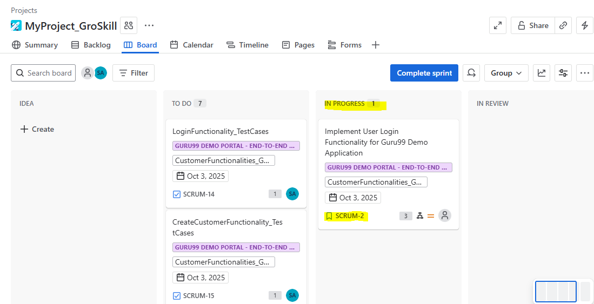

Comment added for the story (SCRUM-2):

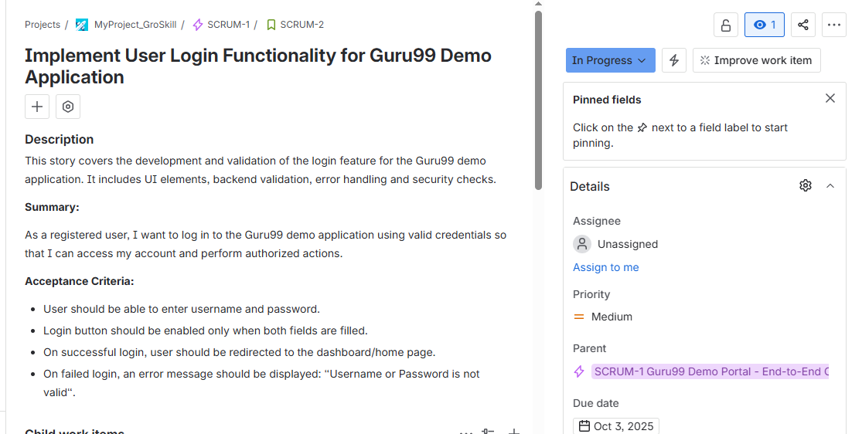

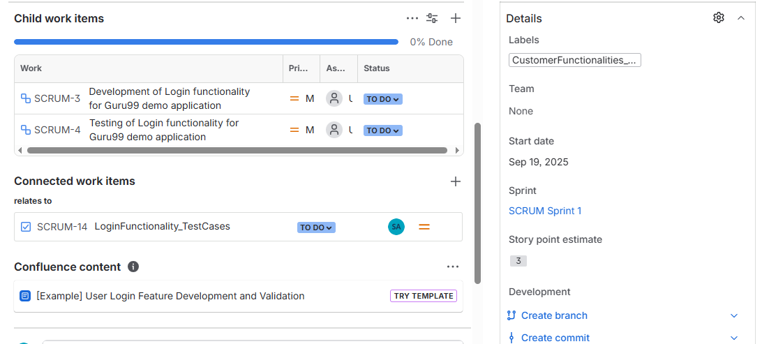

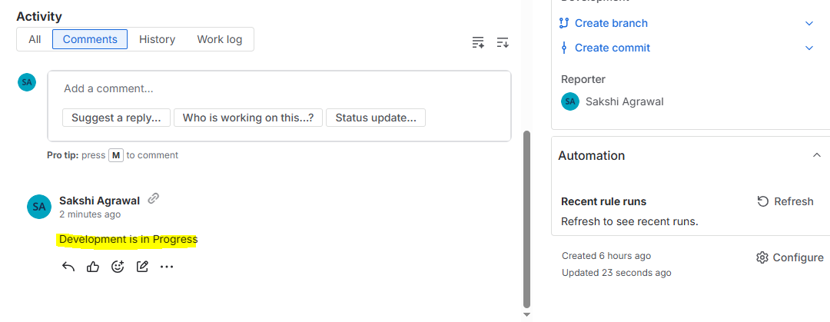

All the tasks moved to “In Progress” status:

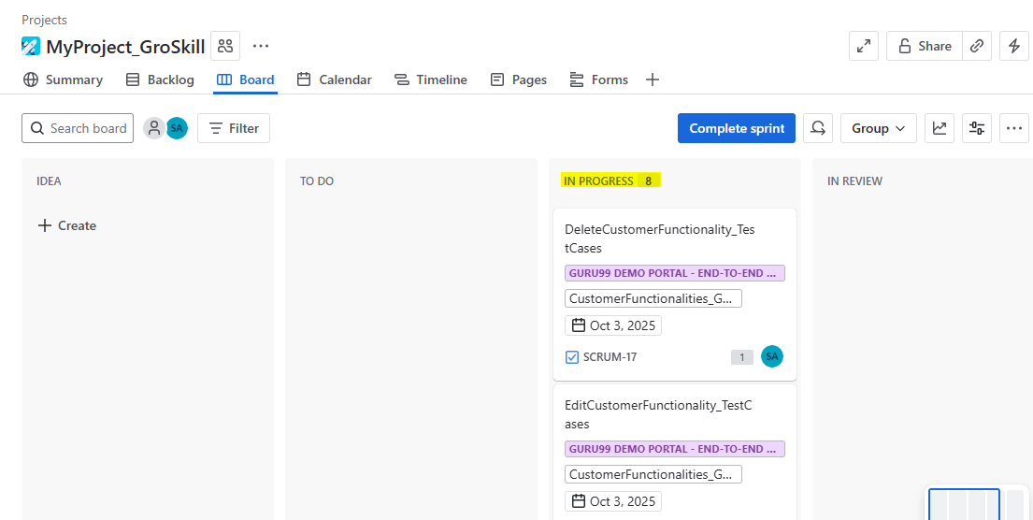

All the user stories and test cases are maked as “Done”:

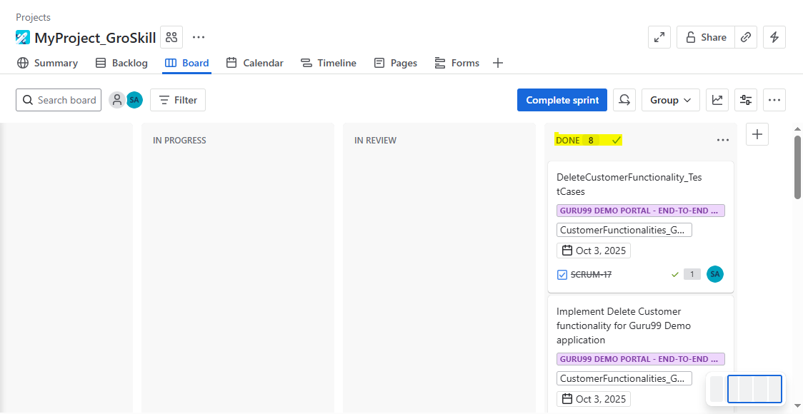

Now, Complete the Sprint:

